DESIGN AND ANALYSIS OF ALGORITHMS
Case Study Report
Search Engine Query Processing Using Binary Search

Name: ATHIVARAM JAYAPRAKASH
Register Number: 192425311
Slot: C
Subject: Design and Analysis of Algorithms (DAA)
Topic: Binary Search — Search Engine Query Processing

1. Introduction
A search engine maintains a massive, sorted index of keywords so that user queries can be matched against relevant documents almost instantly. As the number of indexed keywords grows into the millions, the method used to locate a keyword inside that index becomes critical to the system's overall responsiveness. This case study analyses how Binary Search, a classic divide-and-conquer algorithm, is applied to keyword lookup in a search engine, why the index must remain sorted for the technique to work, and how its logarithmic time complexity makes it the optimal choice over a simple linear scan.
Binary Search operates on a sorted collection by repeatedly comparing the target value (the search key) with the middle element of the current search range, and eliminating half of the remaining elements at every step. This halving behaviour is what allows search engines to look up a keyword among millions of entries using only a handful of comparisons.

2. Key Requirements for Binary Search
For Binary Search to be applied correctly and efficiently within a search engine's indexing pipeline, the following requirements must be satisfied:
- Sorted Data: The keyword index must be maintained in strict lexicographic (alphabetical) order. Binary Search is only valid on sorted data; on unsorted data its comparisons give no guarantee about which half to discard.
- Random Access: The underlying data structure (typically an array-like sorted index or a B-Tree-based structure) must allow O(1) or O(log n) access to any element by position, so the middle element can be located quickly at each step.
- Static or Controlled Updates: Because every insertion or deletion can disturb the sort order, search engines typically batch new keywords and re-sort or merge them into the index periodically, or use self-balancing structures that preserve order incrementally.
- Comparable Keys: Keywords must have a well-defined ordering (e.g., alphabetical/lexicographic comparison) so that "less than", "equal to", and "greater than" comparisons are always meaningful.
- Fast Retrieval Goal: The system requirement driving the choice of algorithm is low query latency — users expect results in milliseconds even when the index holds billions of terms.

3. Applying Divide and Conquer Principles
Binary Search is a textbook example of the divide-and-conquer paradigm, which solves a problem by breaking it into smaller subproblems of the same type, solving each recursively (or iteratively), and combining the results. In Binary Search this pattern takes a very simple form because only one half ever needs to be explored:
- Divide: The current search range [low, high] is split at the middle index, mid = (low + high) / 2, comparing the keyword at that position with the target key.
- Conquer: Based on the comparison, one half of the range is discarded entirely — if the target is smaller, the right half is dropped; if larger, the left half is dropped — and the same procedure is applied to the remaining half.
- Combine: Because at most one recursive call is ever active (unlike Merge Sort, which explores both halves), no explicit combine step is needed — the answer from the surviving half is the final answer.
This process repeats until either the keyword is found or the search range becomes empty (low > high), at which point the keyword is reported absent from the index.
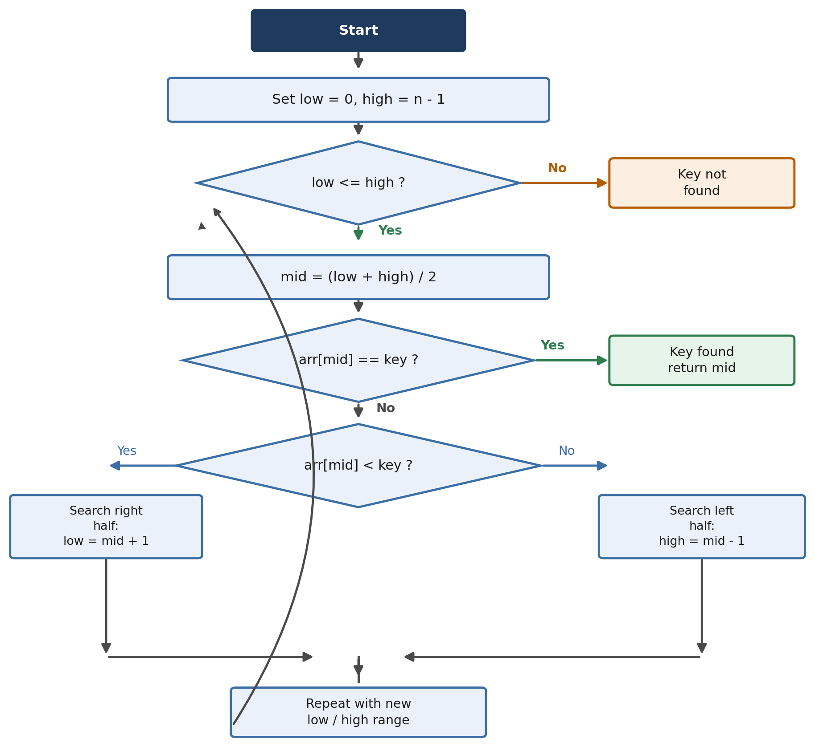
Fig. 1: Flowchart of the Binary Search process applied to keyword lookup

4. Algorithm (Pseudocode)
BinarySearch(index[], key):
low <- 0
high <- length(index) - 1
while low <= high:
mid <- (low + high) / 2
if index[mid] == key:
return mid // keyword found
else if index[mid] < key:
low <- mid + 1 // search right half
else:
high <- mid - 1 // search left half
return -1 // keyword not found

5. Step-by-Step Trace Example
Consider a small sorted keyword index of 15 entries represented here by numeric keys, and a search for the key 56. The trace below shows how the search range shrinks by half at every step until the key is located at index 8, in just 4 comparisons rather than the up to 15 a linear scan could require.
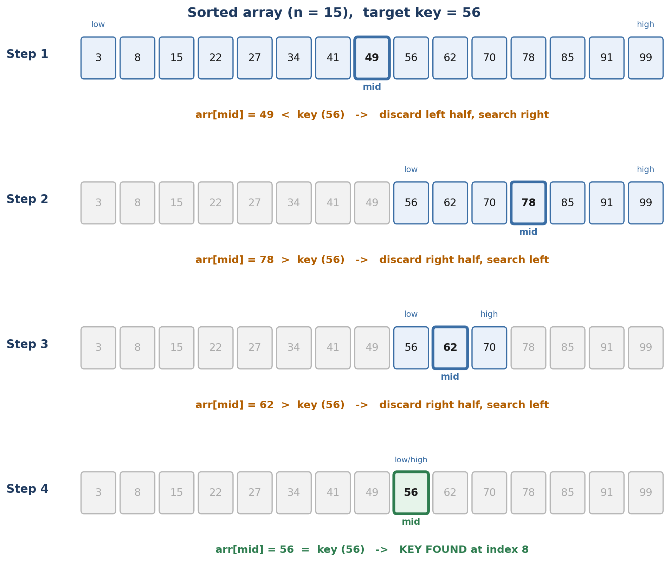
Fig. 2: Step-by-step trace of Binary Search locating key = 56

6. Search Engine Architecture Using Binary Search
Within a search engine's query pipeline, the Binary Search module sits between query processing and result ranking. When a user submits a query, it is tokenized and normalized, then each keyword is looked up in the sorted index using Binary Search. A match points to a posting list — the set of documents containing that keyword — which is then passed to the ranking engine before results are returned to the user.
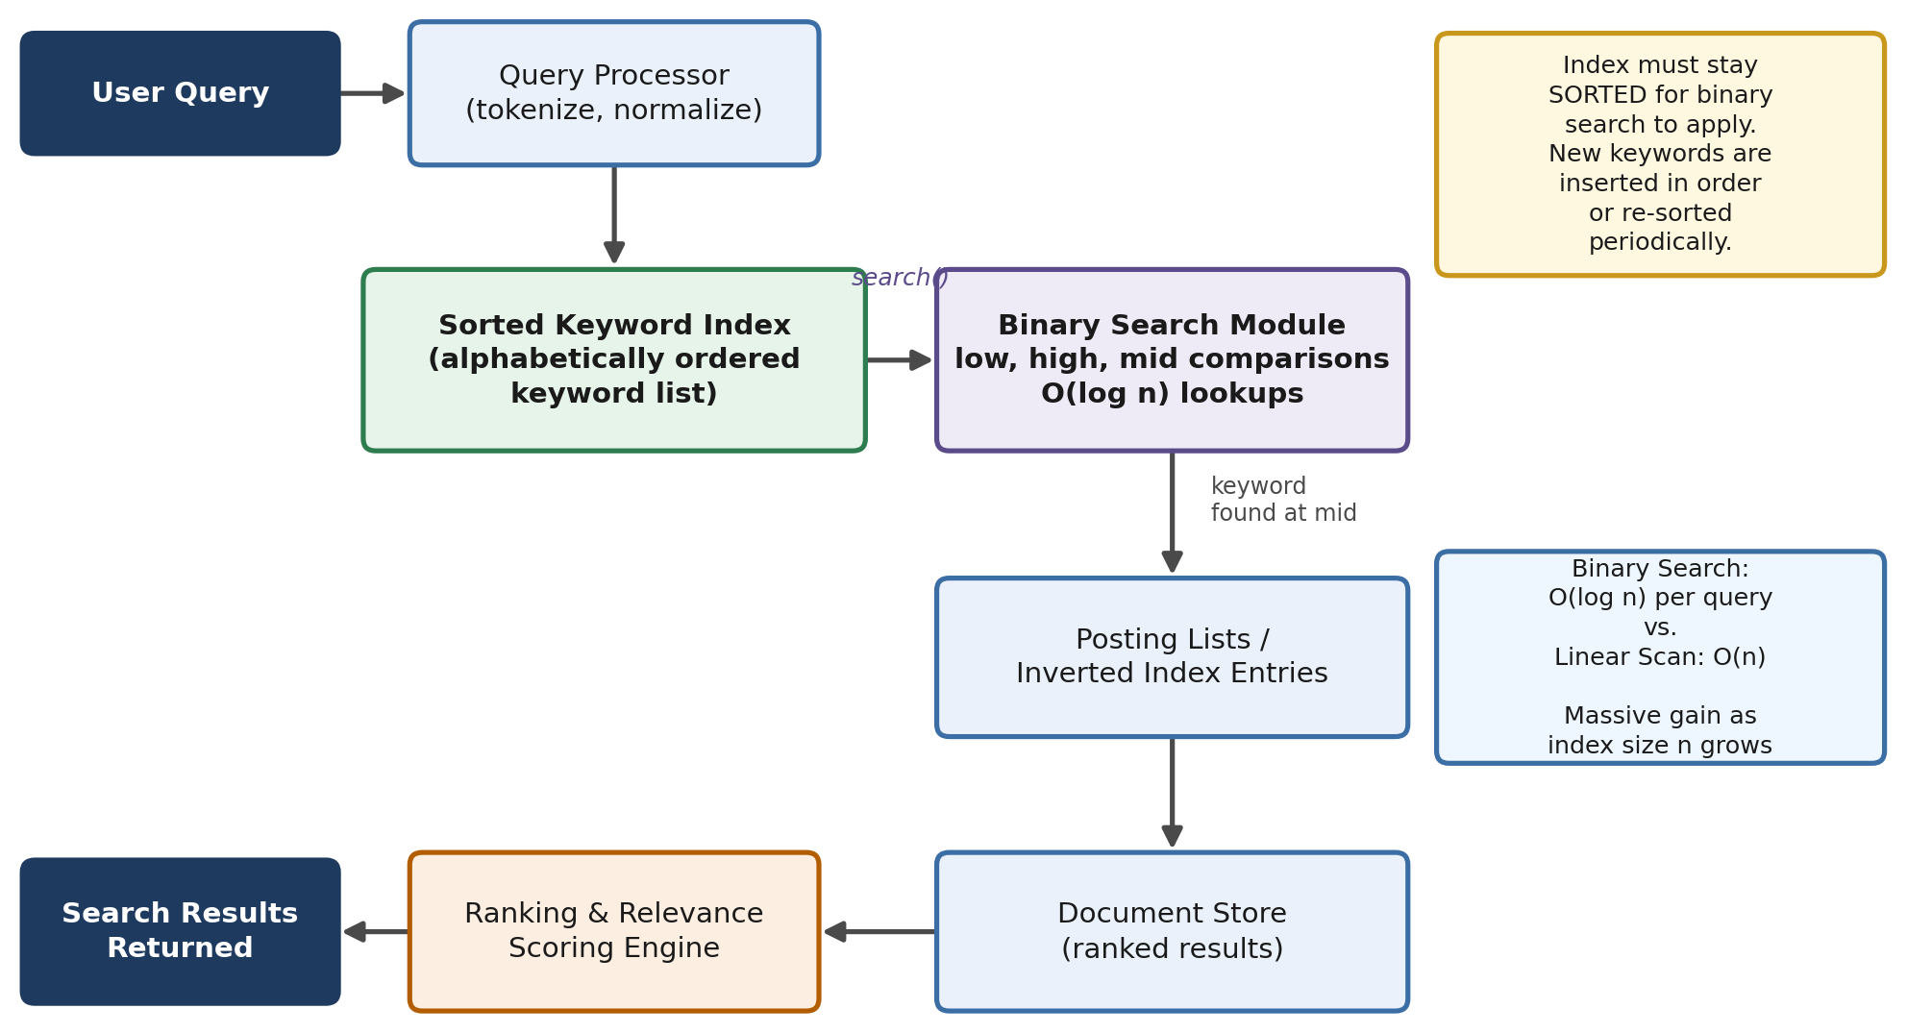
Fig. 3: Architecture of a search engine's query-processing pipeline showing where Binary Search operates

7. Time Complexity and Performance Analysis
The efficiency of Binary Search comes directly from the divide-and-conquer halving of the search range. Each comparison eliminates half of the remaining candidates, so the number of comparisons needed in the worst case is proportional to log₂(n) rather than n.
Case | Time Complexity
Best Case | O(1) — key found at the first middle element
Average Case | O(log n)
Worst Case | O(log n) — key at the boundary or absent
Space Complexity | O(1) iterative, O(log n) recursive (call stack)

The performance gap between Binary Search and Linear Search widens dramatically as the index size n grows, which is exactly the situation search engines face. For an index of one million keywords, a linear scan may require up to 1,000,000 comparisons in the worst case, whereas Binary Search requires at most about 20.
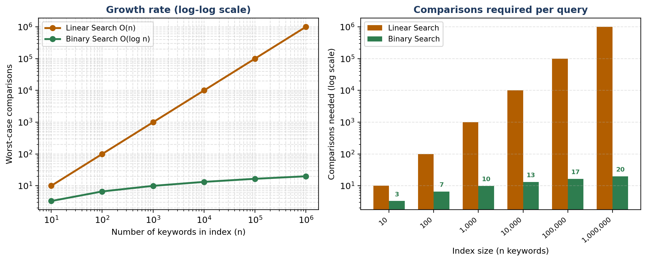
Fig. 4: Comparison of worst-case comparisons required by Linear Search O(n) versus Binary Search O(log n)

8. Design Justification: Why Binary Search Is Optimal
Given the requirements identified in Section 2 and the performance data in Section 7, Binary Search is the most suitable retrieval strategy for a sorted keyword index for the following reasons:
Criterion | Why Binary Search Wins
Query Latency | O(log n) lookups keep response times in the microsecond-to-millisecond range even at web scale.
Scalability | Doubling the index size adds only one extra comparison, so performance degrades gracefully as the web grows.
Predictability | Worst-case and average-case bounds are identical order of growth, giving consistent, predictable latency.
Resource Efficiency | O(1) extra space (iterative form) makes it cheap to run at massive query volumes.
Compatibility | Works naturally with sorted arrays, B-Trees, and skip lists already used in real-world indexing engines.

The one prerequisite Binary Search imposes — that the data be sorted — is a cost search engines already accept, because sorted or tree-structured indexes are needed for other operations too, such as prefix queries and range queries. Given that the index is sorted anyway, Binary Search extracts the maximum possible benefit from that ordering, making it the natural and optimal choice over alternatives such as Linear Search O(n) or unindexed hashing, which cannot support range-based or prefix queries.

9. Conclusion
Binary Search improves search engine query processing by exploiting the sorted structure of the keyword index to eliminate half of the remaining search space at every step, a direct application of the divide-and-conquer strategy. This reduces the time complexity of a keyword lookup from O(n) for a linear scan to O(log n), which is what allows modern search engines to return results from indexes containing billions of terms within milliseconds. The trade-off — maintaining a sorted index — is a cost search engines already bear for other reasons, making Binary Search the most efficient and practical solution for this problem.

References
- Cormen, T. H., Leiserson, C. E., Rivest, R. L., & Stein, C. Introduction to Algorithms. MIT Press.
- Sedgewick, R., & Wayne, K. Algorithms. Addison-Wesley.
- Manning, C. D., Raghavan, P., & Schütze, H. Introduction to Information Retrieval. Cambridge University Press.
- Course notes and lecture material — Design and Analysis of Algorithms (DAA), Slot C.

